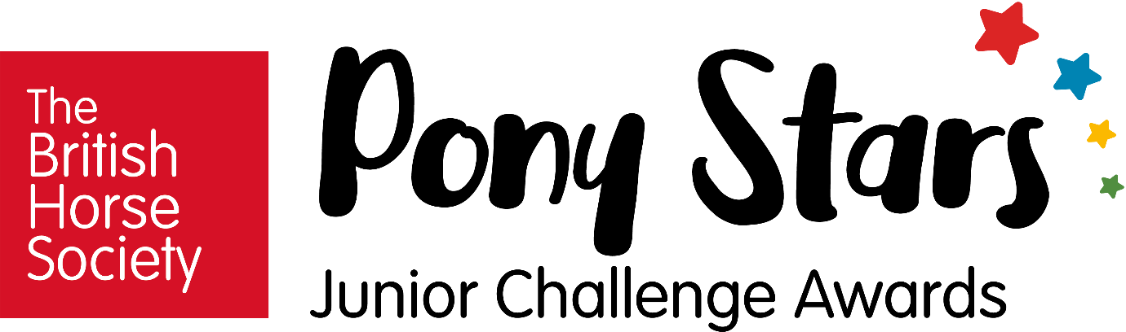

Spencer Club
- Spencer Club will be working towards The British Horse Society ‘Pony Stars’ awards as of Friday 25th June.
- As of Friday 2nd July Spencer Club will be £15 per session.
- As of Friday 2nd July The Stables Bistro will be running ‘Spencer Tea’ at 6pm when Spencer Club finishes.

Pony Stars Awards
Pony Stars Awards help under 12s to discover, develop and nurture their love for ponies and the outdoors. With over 100 topics for children to explore, Pony Stars will ignite a passion for ponies, build knowledge and cement friendships that will last a lifetime.
As part of the programme, each child will receive their very own ‘My Challenge Book’ to log their achievements. As they progress through the various challenges there will be stickers, badges and rosettes up for grabs too to keep them engaged and motivated.
With four key groups, Pony Stars enables long-term progression with a range of activities that will develop knowledge, skills and self-confidence. In each group your child will work through sets of challenges that make up topics within set themes.’

If you would like to register your child please complete the form below (registration is not necessary to attend Spencer Club). All children will work towards the ‘Shetland Strider’ award. Registration for the Shetland Strider Award is £24.99. Once the Shetland Strider Award is complete, children will move on to the ‘Dartmoor Dazzlers’ award.

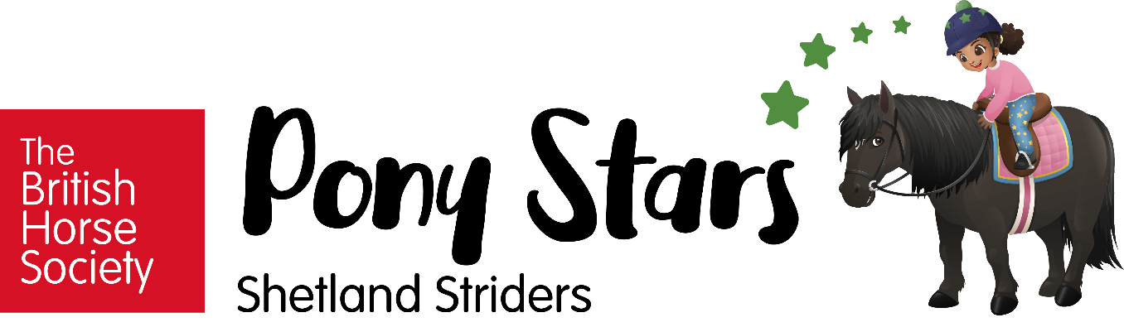

Shetland Striders are courageous and bold; just like Shetland ponies themselves. They will try anything and enjoy getting hands-on and can turn their hand (or hoof) to almost anything.

They will work towards badges that will develop their passion for caring for all animals, wildlife, people and the environment. Shetland Striders will develop core skills like handling ponies and riding through regular lessons which build confidence and commitment.

Shetland Striders will work through topics within six themes which can be completed in any order to suit their individual preferences.
Stickers are awarded upon completion of topics. Once a theme is complete an iron-on cloth badge is awarded. When all themes have been achieved the Shetland Striders rosette and certificate are awarded.

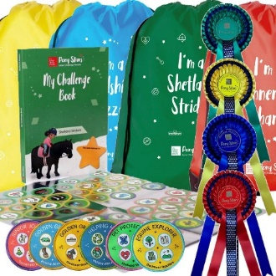
Each ‘Shetland Strider’ registration includes:
- 1x Pony Stars ‘My Challenge Book’
- 2x sticker sheets
- 6x cloth badges
- 1x rosette
- 1x drawstring bag

Spencer Club Registration

Child’s Name:

Emergency Contact Number:

I would / would not like to register my child onto the ‘Shetland Striders’ award at a cost of £24.99, payable to Kirklevington Riding Centre via bank transfer.

Bank Details:
Barclays Bank
20-82-18
40856673
Ref: Pony Stars [Child’s name]

I do / do not give Kirklevington Riding Centre permission to take photographs of my child.
I grant full rights to use the images resulting from the photography, and any reproductions or adaptations of the images for fundraising, publicity or other purposes to help achieve the group’s aims. This might include (but is not limited to), the right to use them in their printed and online publicity, social media, press releases and funding applications.

Parent / Guardian Name:

Parent / Guardian Signature:

Date:

